


INTEGRATED OFFICE APPLICATIONS
(215)

STATE 2021

Production:

Job 1: Outline (100 points)

Job 2: Presentation (240 points)

Job 3: Spreadsheet (125 points)

Job 4: Memorandum with Spreadsheet (125 points)

Job 5a: Certificates ______________ (125 points)

TOTAL POINTS (715 points)

Test Time: 90 minutes

GENERAL GUIDELINES:

Failure to adhere to any of the following rules will result in disqualification:
- Contestant must hand in this test booklet and all printouts if any. Failure to do so will result in disqualification.
- No equipment, supplies, or materials other than those specified for this event are allowed in the testing area. No previous BPA tests and/or sample tests (handwritten, photocopied, or keyed) are allowed in the testing area.
- Electronic devices will be monitored according to ACT standards.

EXAM GUIDELINES:

- Ensure this test booklet contains Jobs 1-5.
- Key all jobs according to the instructions given.
- Correct any and all formatting, spelling or grammar errors. Use the formatting guide in the Style & Reference Manual.
- Your name or initials should not appear on any work you submit. Use your contestant number in any occasion you would normally key your reference initials.
- In the lower right hand corner of ALL work submitted (unless otherwise specified) key your contestant number and job number.
- If you complete the event before the end of the time allotted, notify the proctor. Time could be considered a factor in determining a winner when there is a tie score.
- Place your scoring sheet on top of your Jobs. Jobs should be placed in numerical order.

PRODUCTION STANDARDS
0 Errors | 100 Points
1 Error | 90 Points
2 Errors | 70 Points
3 Errors | 50 Points
4+ Errors | 0 Points

SCORING RUBRIC
Job 1 – Outline |  | Possible Points | Points  Awarded
Production Standards:  0 Errors – 100 points, 1 error – 90 points, 2 errors – 70 points,  3 errors – 50 points, 4 or more – 0 points |  | 100
Total |  | 100
Job 2 – Slideshow |  | Possible Points | Points Awarded
Production Standards:  0 Errors – 100 points, 1 error – 90 points, 2 errors – 70 points,  3 errors – 50 points, 4 or more – 0 points |  | 100
Slide 1 | Title content and formatting | 5
 | Subtitle content and formatting | 5
Slide 2 | Correct slide layout | 5
 | Title correct and formatted | 5
 | Graphic placement and formatting | 5
 | Bulleted list placement and formatting | 5
Slide 3 | Correct slide layout | 5
 | Title correct and formatted | 5
 | Graphic placement and formatting | 5
Slide 4 | Correct slide layout | 5
 | Title correct and formatted | 5
 | Graphic placement and formatting | 5
Slide 5 | Correct slide layout | 5
 | Title correct and formatted | 5
 | Graphic placement and formatting | 5
 | Bulleted list placement and formatting | 5
Slide 6 | Correct slide layout | 5
 | Title correct and formatted | 5
 | Graphic placement and formatting | 5
 | Bulleted list placement and formatting | 5
Slide 7 | Correct slide layout | 5
 | Title correct and formatted | 5
 | Graphic placement and formatting | 5
 | Bulleted list placement and formatting | 5
Slide 8 | Correct slide layout | 5
 | Title correct and formatted | 5
 | Graphic placement and formatting | 5
 | Bulleted list placement and formatting | 5
TOTAL |  | 240
Job 3 – Spreadsheet |  | Possible Points | Points  Awarded
Production Standards:  0 Errors – 100 points, 1 error – 90 points, 2 errors – 70 points,  3 errors – 50 points, 4 or more – 0 points |  | 100
Separated Last Name, First Name into two columns |  | 25
TOTAL |  | 125
Job 4 – Memorandum |  | Possible Points | Points Awarded
Production Standards:  0 Errors – 100 points, 1 error – 90 points, 2 errors – 70 points,  3 errors – 50 points, 4 or more – 0 points |  | 100
Spreadsheet Inserted |  | 25
TOTAL |  | 125
Job 5a - Certificate |  | Possible Points | Points Awarded
Production Standards:  0 Errors – 50 points, 1 error – 45 points, 2 errors – 35 points,  3 errors – 25 points, 4 or more – 0 points |  | 50
Effective use of fonts, types styles, and type sizes |  | 25
Creativity (eye catching) |  | 10
Printed landscape |  | 25
Printed Larsen Smith Certificate |  | 25
TOTAL |  | 125

GRAND TOTAL

Job 1: Outline – 100 Points

SOCIAL MEDIA POLICY

- AGENDA

  - Know and Follow the Rules
  - Be Respectful
  - Be Honest and Accurate
  - Post Only Appropriate and Respectful Content
  - Media Contacts

II. ABOUT DIGITAL SOLUTIONS

  - Digital Solutions Develops and Sells
    - Software
    - Hardware
    - Services
  - Management Includes
    - Chief Executive Officer
    - Financial Services Department
    - Information Technology Department
    - Human Resource Department
    - Administrative Support Department

III. KNOW AND FOLLOW THE RULES

  - Read Guidelines
  - Inappropriate Postings
    - Discretionary Remarks
    - Harassment
    - Threats of Violence

IV. BE RESPECTFUL

  - Always be Fair and Courteous
  - Open Communication Policy
  - Posting Complaints or Criticism

V. BE HONEST AND ACCURATE

  - Make Corrections
  - Internet Archives
  - Rumors

VI. POST ONLY APPROPRIATE AND RESPECTFUL CONTENT

  - Confidentiality
  - Respect Financial Disclosure
  - Do not Link to Digital Solutions
  - Express Only your Opinions

VII. MEDIA CONTENT

  - No Speaking on Company's Behalf
    - Contact Public Relations or Legal

Production Standards (100 points)
  - 0 errors = 100 points; 1 error = 90 points; 2 errors = 70 points; 3 errors = 50 points; 4+ errors = 0 points
- Top margin 2”, left, right, and bottom margins 1”
- Capitalization of words in outline may vary—look for consistency.

Job 2: Presentation – 240 Points

Notes to Graders:

- Production Standards: (100 points)
  - 0 errors = 100 points ; 1 error = 90 points; 2 errors = 50 points; 3 errors = 50 points; 4 or more = 0 points

- Use the rubric to assign points as indicated. Each item is worth 5 points as indicated on the rubric.

Job 3: Spreadsheet – 125 Points

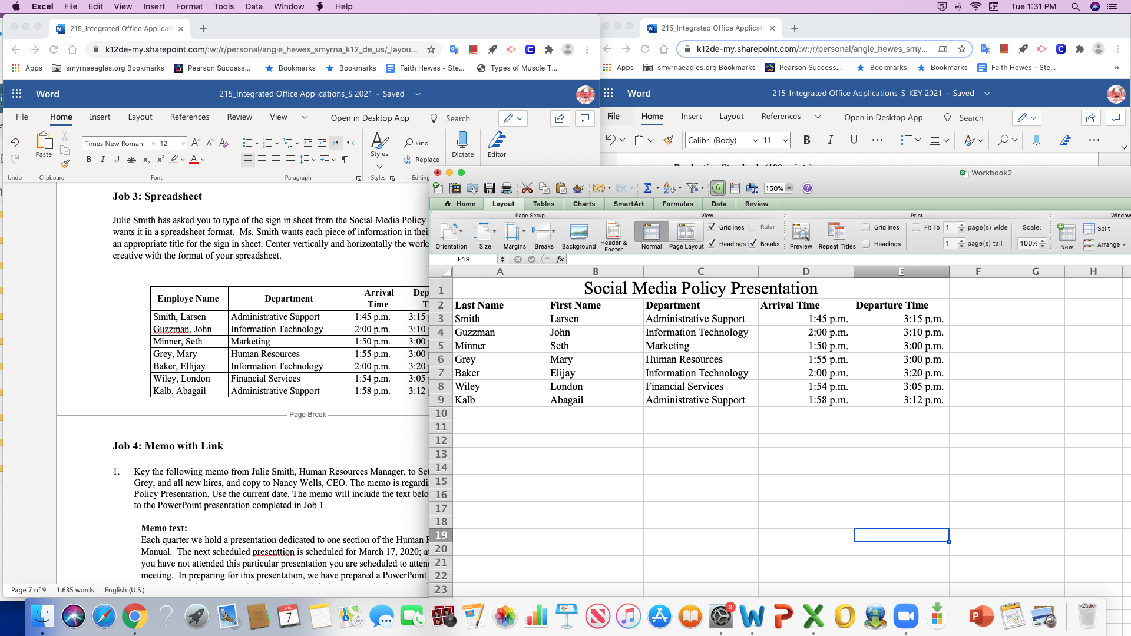

Note to Graders:
- Production Standards: (100 points)
  - 0 errors = 100 points ; 1 error = 90 points; 2 errors = 50 points; 3 errors = 50 points; 4 or more = 0 points
- Spreadsheet may be in any format. Spreadsheet should be centered horizontally and vertically on page.
- Names should be separated, first name and last name and can be in any order.
- Title may vary.

Job 4: Memo with Spreadsheet – 125 Points

MEMORANDUM (16 point font)

TO: Nancy Wells, CEO

FROM: Julie Smith, Human Resource Manager (Resources is also correct)

CC: Roger Meyer, Marketing Manager

DATE: Current Date

SUBJECT: Attendance at Social Media Policy Presentation

As requested, here is the information of those attending our recent Social Media Policy Presentation. You indicated you wanted the information so you can record it under their professional development hours for the year.

Please advise if you require any additional information or have any questions. The session was very well received, and many positive comments were received as feedback.

xx (Contestant ID)

Note to Graders:
- Production Standards: (100 points)
  - 0 errors = 100 points; 1 error = 90 points; 2 errors = 50 points; 3 errors = 50 points; 4 or more = 0 points
- Spreadsheet Inserted: (25 points)
- Subject line wording may vary.

Job 5a: Certificate – 125 Points

- See Rubric for scoring original Certificate with Merge Codes.

Production Standards (100 points)
  - 0 errors = 100 points; 1 error = 90 points; 2 errors = 70 points; 3 errors = 50 points; 4+ errors = 0 points
  - Creativity – 10 points

Job 5b: Certificate (Larsen Smith) – 25 Points

- Printed Larsen Smith’s certificate from the Social Media Policy Presentation.
- Printed in landscape orientation.

